LAB #6
CST 238 - GUI PROGRAMMING
Hooking up Child Window Controls

First of all: Compile and run each of the sample programs for chapters 9 & 10. View the source code, and make sure you understand each function call. Experiment with some changes and see what happens. The purpose of this lab is give you experience with:
- Creating child windows controls
- Hooking up child window controls, so that they work together

Next: Follow these steps:
- Copy the Lab6 folder (or download from the web) to your desktop. This is our same basic HelloWin project, but I’ve started you off with some data structures and the skeleton of the WM_COMMAND message processing.
- Display your name and LAB 6 – Address Book in the window caption
- Add child window controls (two static text controls, two edit controls, three buttons, and one listbox) to create a window that looks like something this. The layout does not have to be exactly the same. And of course, your window will contain any data yet.

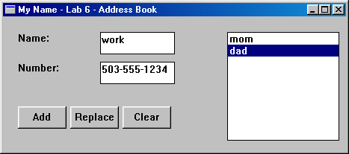

- When the program starts up, and there is nothing in the list, the Replace button should be disabled.
- When the user selects the Add button, save the contents of the Name and Number fields, and add the item to the list (use the name only). Make sure the new item is selected in the list.
- When the user selects the Clear button, clear the contents of the Name and Number fields, and clear the list selection (so there is nothing selected). Also disable the Replace button.
- When the user selects a different item in the list, set the contents of the Name and Number fields to the saved name and number for that selected item. Make sure the Replace button is enabled when an item is selected in the list.
- When the user selects the Replace button, save the contents of the Name and Number fields in the currently selected item, and update the name of the item in the list. Note: you could implement this as a modification of an exisiting list item, or you could implement it as a delete+insert (your choice). Make sure the replaced item is still selected in the list when the replace is finished.
- If either the Name or Number field is blank when the user selects Add or Replace, show a message box that explains what the error is, and don’t do the add/replace action.

Extra Credit: Add a Delete button that deletes the currently selected item. Make sure you correctly handle the information in the array, so that future add & replace operations still work properly.

